1. Calculate the complex power of three-phase load (use the parameters of elements from your variant).

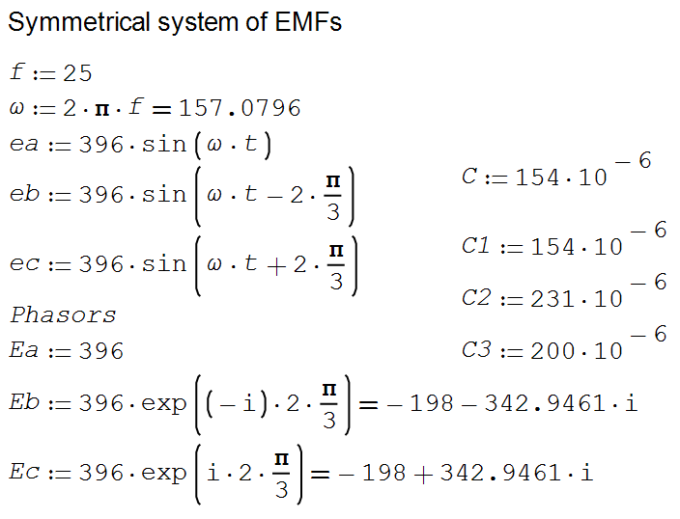

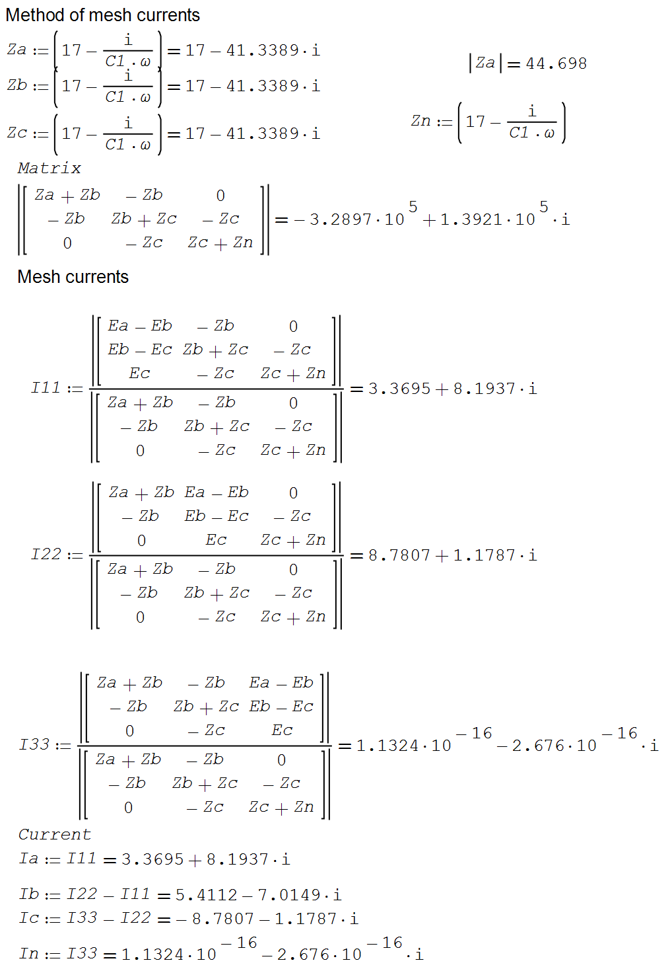

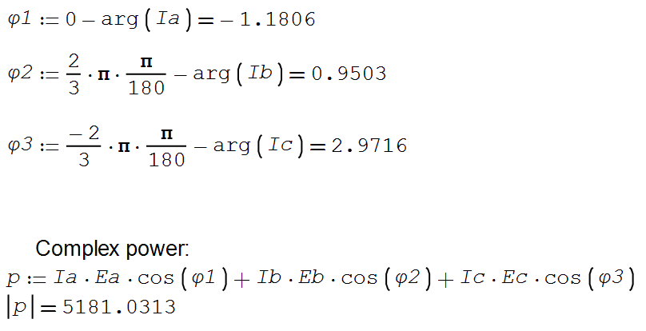

1. Calculate the parameters of reactive power compensation bank (delta-connected). Use capacitors if the imaginary part of complex power is positive. Use the inductors if the imaginary part of complex power is negative.

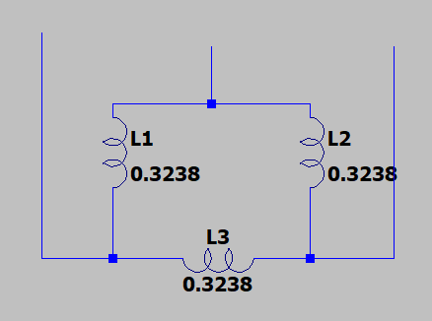

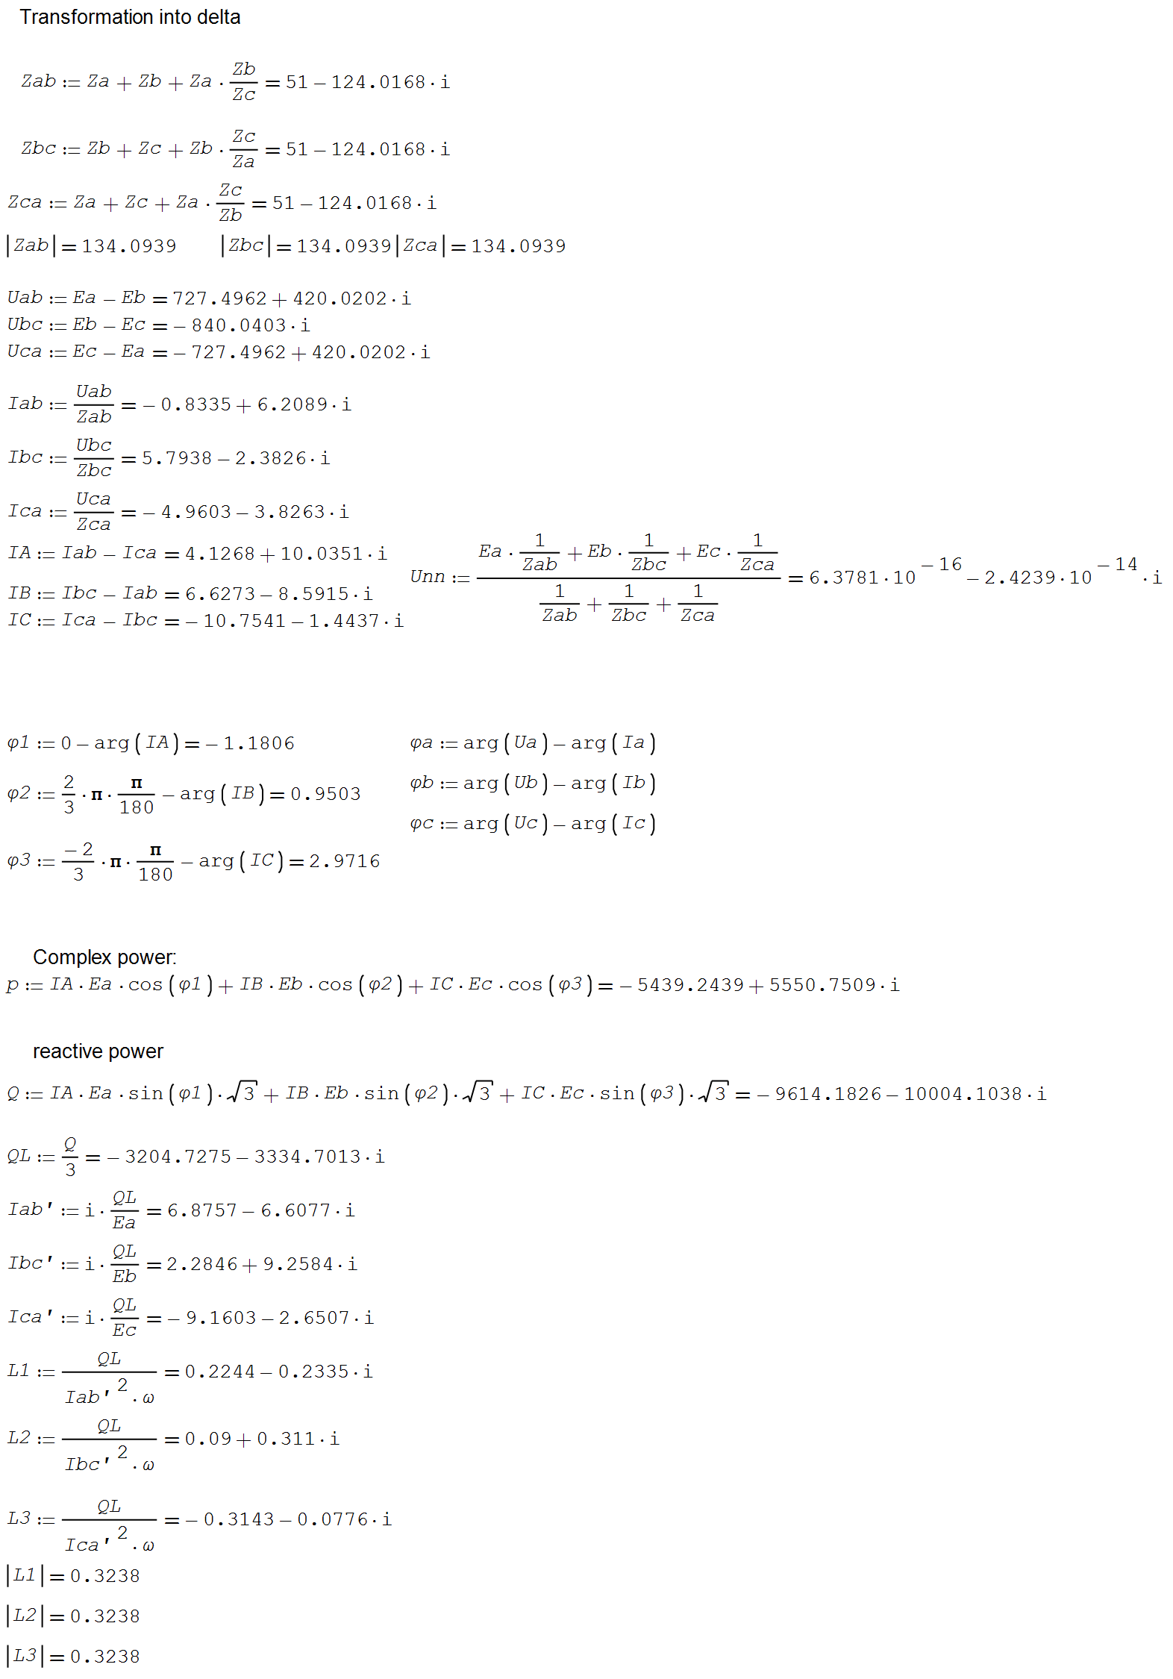

3. Calculate the compensated complex power of a three-phase load with reactive power compensation bank connected. The imaginary part of complex power, in that case, must be close to zero.

